Guidebook for International Students
International School of Chinese Studies (ISCS) Shaanxi Normal University (SNNU)
陕西师范大学国际汉学院留学生指南
Dear International Students,
Welcome to the International School of Chinese Studies of Shaanxi Normal University. We hope this Guidebook for International Students will be of help to you with your study and stay in Xi’an as well as at our university. We wish you a pleasant stay and success in your study.
亲爱的各位留学生同学，欢迎来到陕西师范大学国际汉学院学习！希望这本小册子能为你在西安、在我校的学习和生活提供一些帮助，并预祝你学习进步、生活愉快。
I. Arriving at Xi’an & Getting to SNNU到达西安、找到学校
1.1 Xi’an Xianyang International Airport: 西安咸阳国际机场
is about 40 kilometers away from the city of Xi’an and about 50 kilometers away from SNNU Yanta campus. Shuttle bus service to downtown Xi’an is available for RMB25 yuan, leaving airport for downtown every half an hour and it takes about one hour. Then you may take a taxi to get to SNNU, Yanta campus for about RMB15 yuan fare. You can take a taxi at the airport to come to SNNU, Yanta campus for about RMB130 yuan fare. 距离西安市区约40公里。距离陕西师范大学约50公里。机场大巴每隔半小时一班，到达市区约一小时，票价25元。再换乘出租车就可到达陕西师范大学，车费约15元。从机场乘出租车直接到陕师大，时间约一小时，车费约130元人民币。
1.2 Xi’an Railway Station: 西安火车站
is about 5 km from downtown and about 15 km from SNNU. You may take the double-decker bus No. 603 from railway station to SNNU at one RMB yuan fare only or you may take a taxi at about RMB 20 yuan fare. 距市中心5公里，距陕师大约15公里。火车站广场有603路公共汽车直达陕师大，车费1元人民币。乘出租车约需20元人民币。
II. Report for Registration 到校报到注册
2.1 Time for Registration 报到注册时间
The time for registration begins the 3 working days (weekdays) before the opening day of each semester, which are scheduled on March 1 for spring semester and Sept. 1 for fall semester. It will be postponed to the next Monday if it falls on a weekend. The first day is for placement test in the morning and the classes begin the following day. If you missed the test, just come to the Int’l Students Office and we will assign you to a suitable class. 报到时间从每学期开学日前的3个工作日（周一至周五）开始，春季学期3月1日开学，秋季学期9月1日开学。如遇周末顺延至下一个周一开学。开学第一天举行分班考试，第二天开始上课。如错过分班考试可直接到留学生办公室说明情况，可以安排班级。
2.2 Registration Procedure 报到注册程序
2.2.1 After checking into the on-campus Qixiayuan hotel (Spot B on the campus map at the end of this Guidebook) or settled down in your rented off-campus apartment, please come to the International Students Office (ISO) on the 2nd floor of Classroom Building No. 2 (Spot A on the map)for registration bringing your passport, 2 photocopies of passport name & photo page, one photocopy of visa page (all on A4 size papers), and 5 recent photos (2.5 x 3.5cm) (You can get photo taken or passport photocopied at digital photo studios or photocopying shops inside or near the school). Please also bring and return the Visa Application for Study in China (JW202 Form) and Admission Notice we sent to you. 新生到达西安入住校内启夏苑宾馆（见本指南最后校园地图B点）或校外租住处后，须到位于教学二楼（见校园地图B点）二层的留学生办公室报到注册，请携带护照、护照姓名照片页复印件2张、签证页复印件1张（均为A4尺寸）及近期照片1吋5张。（可以到校内或学校附近的数码照相馆照相或复印部复印）请同时携带、交回《外国来华人员签证申请表表（JW202）》和《入学通知书》。
2.2.2 Fill in the “Registration From”, read and sign the “Safety Obligation for International Students” and pay the tuition, application and registration fee and (accident & injury) insurance fee (in RMB cash only) to complete your registration. 报到时需要填写“注册登记表”、签署“留学生安全责任书”并交纳学费、申请注册费和（意外伤害）保险费（只收人民币现金）。
2.2.3 Present your passport for examination of the validity of your current visa and to see if you need a visa extension, otherwise you may be subject to a fine of RMB500 yuan per day for illegal stay. 请交验护照以查看你现持签证的有效期，并了解是否需要办理签证延期手续，否则若是非法超期居留将被罚款每天500元。
2.2.3 Come to the lobby of Classroom Building No. 2 at 8:30AM to take the Placement Test where you will be met with our teachers and taken to classrooms to take test. The Name List of each class and class Schedule will be released in the afternoon or the next morning. Purchase the textbooks of your class at the Reference Room at the east end of 1st floor, but please note it is advisable to try the classes for a day or two to decide if they are really suitable for you before you buy, for sold textbooks are not returnable or exchangeable. 分班考试从上午8点半开始在教学二楼举行，请在一楼大厅等候老师安排你参加考试。下午或第二天上午公布分班名单和课表。请到一楼东头的资料室购买你所在班级需要的教材，但请注意教材售出后不予退换，所以建议先上一两天课、确定班级后再买。
III. Living (on / off Campus) & Dining（在校内/外）住宿和就餐
3.1 Qixiayuan Hotel (Foreign Affairs Service Center) is a 3-star hotel located within the Yanta campus. Students may stay there for favorable rates, and are required to pay monthly and pay a 30-day deposit of RMB 1200 yuan at the rate of RMB40/day/bed when checking in. When checking out, the rent is re-calculated according to the actual length of stay (RMB 40 yuan /day/bed or 80 yuan /day/room for in twin-bed room for staying for full semester or longer, or RMB 60-80 yuan /day/bed or 120-160 yuan /day/room for shorter stay). 启夏苑宾馆（外事服务中心）位于雁塔校区内，对留学生价格优惠，入住时先按40元/天/床交纳一个月的押金1200元，按月付房费，退房时依实际入住时间长短不同重新计算收费（注满一个学期或以上为40元/天/床或80元/天/间，不足一个学期则为60-80元/天/床或120-160元/天/间）。 Please ask for a copy of the Hotel Registration Note from the Front Desk, which copy is required for visa extension. 请向前台索取“住宿登记单”供申请签证延期时使用。
3.2 You may move out of Qixiayuan to rent / share an off-campus apartment/flat at the nearby residential communities through local real estate agents, but the university does not provide this service. You should take your lease contract and passport to register and obtain the “Registration Form of Temporary Residence” at the local police station supervising the area of your current address (the local one is the MingDeMen Police Station, at the entrance of XiBaLiCun along Chang’an Nanlu). You must present a copy of the Form to the ISO for registration and another copy is required for visa extension. Any change in residence must be registered again at the local police station and the ISO, or you will be fined by the police. 你可以从启夏苑搬出并通过房屋中介代理机构在校外租房居住，但学校不负责安排或联系。你应该持租房合同和护照到居住地派出所（本地派出所为明德门派出所，位于长安南路西八里村口）登记并取得“临时住宿登记表”。请将此表复印件一份交留学生办公室登记，另一份办理签证延期用。搬家须再到派出所和留学生办公室登记，否则会受到警方处罚。
3.3 You can eat at the Chinese Cuisine and Western Restaurant of Qixiayuan Hotel, whether or not you are staying in it. You may also eat at the several Students Canteens (Dining Halls) on campus (including a Moslem canteen), where you will need a Campus Card obtainable at the window at the southwest corner of 1st floor of Xuezi Canteen (XueZi ShiFu) with your Student ID Card. The Campus Card itself is RMB 20 yuan and you need to deposit some money as prepayment in order to buy food. Of course there are many restaurants around the campus for you to choose from. 不论是否在启夏苑住宿，均可在启夏苑的中餐厅和西餐厅就餐。也可以到校内的各个学生餐厅（其中有一个穆斯林餐厅）就餐。在学生餐厅就餐需要办理“校园卡”，可凭 “学生证”到“学子食府”一楼西南角的窗口办理。“校园卡”成本费为20元，你还需要存入一些钱作为预付款来买饭菜。当然学校周围还有许多餐馆供你选择。
IV. Class Arrangements & Attendance课程安排和考勤
4.1 We have two different programs: the Regular Program and the Sunrise Program. The Regular Program opens to students from all countries. The textbooks are in Chinese and it is also the language of classroom instruction. There are 4 compulsory classes each morning from 8:00 AM to 12:00 noon, Monday to Friday. The Elective courses, such as Taijiquan, Calligraphy and Folksongs, etc. during 2:30 to 4:30 are open to application in the 1st week and starts in the 2nd when there are 8 applicants or more. 分为普通班和晨星班。普通班对各国学生开放，使用以中文为主的教材并使用汉语授课。必修课上课时间为周一至周五每天上午8至12点4节课，每节课50分钟。下午2点半至4点半安排有太极拳、书法、HSK辅导、民歌等选修课，有兴趣者开学第一周报名，满8人报名第二周开课。The Sunrise Program uses the 5-volume textbook “Chinese Made Easier” compiled mainly in English and only opens to students whose native language is English or who is proficient in English, and applicants must contact the program coordinator at shidalanguage@yahoo.com for their approval of admission. 晨星班使用一套用英语为主编写的5册教材《实用速成汉语》，只收英语为母语或熟练使用英语的欧美国家学生，须向其联络人或负责人申请(shidalanguage@yahoo.com)获准后方可入学。
4.2 The students are checked attendance for class and must attend classes regularly. Leave of Absence on sickness or other personal affairs must be submitted before or after the absence. Attendance is taken into account in the final grades and too much absence from class may result in not only disqualification for final exams, but also as serious as penalty or cancellation of student visa from the police. 学校定期考勤，学生必须按时上课，有事或生病不能上课应提前请假或事后补假。出勤情况计入期末成绩，缺课次数太多超过规定者不但不得参加考试，并且可能因此受到警方的处罚，被注销学习签证。
V. Student ID Card, Examinations and Certificate of Completion 学生证、考试和结业证书
5.1 Student ID Card will be made and issued about two weeks after the opening day of each semester, as long as you have submitted enough photos as required. For those who apply and register later, the card will be issued two weeks after registration. 交够要求的照片后，学生证在每学期开学后两周左右办好、发放。中途插班生的学生证在注册后两周之后发放。
5.2 There are final exams but no mid-term exams, with class performance counting in the final grades. According to our Rules on Examinations, students who are absent from more than one thirds of classes or not complying with other requirements are not permitted to take the exams. 每学期末有期末考试，没有期中考试。课堂表现计入期末成绩。按照我院考试规则，缺课超过三分之一或不符合其他条件者不得参加考试。
5.3 Certificate of Completion is available after successful completion of required courses and exams and by application with one photo (3.5x5.3cm) sent to the International Students Office at least two weeks before the date of leaving school. The students who fail or do not take the exams can apply for a descriptive Certificate of Study. 结束学习并需办理“结业证书”的留学生须完成必修课程和考试合格，并至少于离校前两周提出申请、交2吋照片一张。未参加考试或考试不合格的学生可以申请写实性的学习证明。
VI. Visa and Health Examination 签证和健康检查
6.1 The ISO prepares required visa approval documents for registered international students without extra handling charge, but they are required by the Xi’an Public Security Bureau to go to the Visa Office of its Division of Exit-Entry Administration in person to present the application documents for visa extension or conversion and pay visa fee (usually RMB 400 yuan for less than one year and 800 yuan for less than two years, starting from the date of documents presentation), and the visa is extended for the period of time as covered by the tuition payment receipt. 国际汉学院留学生办公室为注册留学生准备签证延期所需批准文件，不收取额外费用。按西安市公安局的有关规定，留学生本人需亲自到出入境管理处签证科提交申请材料办理签证延期、变更手续并交纳签证费（一般为一年内400元，一年至两年800元，从提交材料之日起算），延期期限以学费收据所示已支付学费期限为准。
Please also prepare by yourself the copies of the name/photo page and visa page (and /or customs entry stamp page) of passport, tuition payment receipt, Registration Form of Temporary Residence and your photos. 同时需自行准备护照姓名照片页、签证页和/或海关入境印章页、学费收据、“临时住宿登记表”的复印件和照片。
At the end of semester, if students wish to continue their study next semester and need to extend visas, they should come and apply to the ISO at least 7 to 10 working days before the expiration of their current visas (but must before the beginning of winter or summer vacation), and pay application fee RMB 400 yuan (not refundable if they do not register and pay tuition for next semester, or becomes part of tuition when they come to register and pay tuition). 学期将要结束而学生欲申请下学期继续学习需申请延期者必须于签证到期日前至少7至10个工作日向留学生办公室提出申请（但必须是在放寒假或暑假之前），并交纳申请费400元（若未报到交下学期学费则不予退还，若报到交学费则充作部分学费）。
西安市公安局出入境管理处签证科 Visa Office, Entry & Exit Administration of the Xi’an Public Security Bureau 地址：西斜七路（太白南路与科技路交口西南角）“交通指挥中心大楼”2层，办公时间为周一至周五 Add: 18 F, JiaoJin Zhidui Zhihui Zhongxin Dalou (Command Center Building of Xi’an Traffic Police), Xi Xie Qi Lu (southwest corner of the intersection of Taibai Nanlu and Keji Lu), opening from Monday to Friday.
Present your passport and the whole set of approved visa documents obtained from the ISO to the Visa Counter on the 2nd floor, get the “Visa Fee Notice & Certificate” after the documents are accepted by the visa officer, go to the Visa Fee Counter on the 1st floor and pay the visa fee to get the “Visa Fee Notice & Collection Voucher” stamped, give back the stamped Visa Fee Certificate to the visa counter and you can come back with the Visa Fee Certificate in about 3-5 working days to get your passport back with the extended new visa. 请将从留学生办公室取得的全套签证材料和你的护照交至二楼的签证柜台，签证官接受材料后会给你开具“交费通知单和取证凭证”，到一楼的交费柜台交纳签证费、盖章后将交费单交回二楼签证柜台，就可以凭取证凭证在大约3-5个工作日后取回办好新签证的护照。
Students who need to extend their spouses, parents and/or children’s visas must provide copies of Marriage/Birth Certificate, etc. verified by Chinese embassy or consulate with typed and printed Chinese translations.学生申请为其配偶、父母、子女办理签证延期，须提供有中国驻外使领馆验证的结婚证明、出生证明等的复印件，并附打印好的中文翻译件。
6.2 Students who are expected to extend the visa and/or change current visa to a student visa must have the Health Examination at the designated examination center: Shaanxi International Travel Health Care Center. Please note that those who have done it for visa applying purpose before entering China must take the examination report to the center for re-examination and verification, which may be recognized wholly and new report required for visa extension will be issued against the recognized report. If it is recognized partially or rejected, the examination must be done again, partially or wholly. The ISCS will take new students to the center during the 2nd week of new semester. The full examination fee is RMB392 yuan and you pay less for partial examination or issue of new report. Take one A4 size passport copy and four white-background photos (3.5 x 5.3cm) with you. You go there in the mornings without eating breakfast and take your report back three working days later in the afternoon. 需办理签证延期及转学生签证的学生，必须到指定的体检中心：“陕西国际旅行卫生保健中心”做健康检查。来中国前为申请签证做过体检的学生请携带体检报告供查验，经认证则可换发新体检报告。若不能认证则需要重新做全部或部分体检项目。国际汉学院将于开学后第2周组织新生前往体检。全套体检需要体检费392元人民币，部分体检和换证交部分费用。请带护照复印件1张和2吋白底照片4张，不吃早餐，上午体检，3个工作日后的下午取证。
陕西国际旅行卫生保健中心 Shaanxi International Travel Health Care Center
地址: 含光路10号陕西出入境检验检疫局大楼内 Add: No. 10, Han Guang Lu, Building of Shaanxi Entry-Exit Inspection & Quarantine Bureau 周一至五上午morning (Monday to Friday)乘坐K631路公交车到唐城宾馆站下车向北步行约400米即到 Take Bus No. K631 to Tang Cheng Hotel stop & walk about 400m northward
VII. Shopping, Banking and Postal Service: 购物、银行和邮政服务
7.1 Shopping: There are several big supermarkets adjacent to SNNU, such as “CRC Vanguard” located just 200m north of the SNNU main entrance and the “Lotus Center”. The “Metro” supermarket requires membership card and a Letter of Introduction is obtainable at the ISO for you to apply for it. 陕西师范大学附近有多座大型超市，其中有距陕师大正门仅200米的“华润万家”，还有“易初莲花”。 “麦德龙”超市实行会员卡制度，留学生办公室可以出具“介绍信”供你申领会员卡。
7.2 Banking: There are several banks adjacent to SNNU: Bank of China, China Construction Bank, Industrial and Commercial Bank of China, Xi’an City Commercial Bank and Postal Savings. You can exchange foreign currency at the Bank of China (with your passport and a copy of it). 学校附近有多所银行，包括“中国银行”、“中国建设银行”、“中国工商银行”、“西安市商业银行”和“邮政储蓄”。在“中国银行”可以兑换外币（需要护照及护照复印件）。
7.3 Postal Service: There is a Post Office located in the middle of Shida Lu (Road), where you can send letters and parcels, EMS, as well as remit money. It also provides Postal Savings service and West Union remittance service. 师大路中段有一所邮局，除了邮寄信件、包裹、特快专递、汇款之外还提供邮政储蓄和“西联汇款”服务。
VIII. Academic Calendar of ISCS 国际汉学院的学年日程安排
8.1 Spring Semester: 春季学期
8.1.1. The 3 days before March 1: Students arrival, registration and fee payment; March 1: placement test; 3月1日前3天：迎接新同学、报到注册、交纳学费，3月1日分班考试
8.1.2. The 1st week after March 1: Class starts; Orientation and Lecture given by foreign administration police officer on Foreign Administration Regulations (Law on the Entry and Exit of Aliens of the People's Republic of China) for new students 三月一日后第一周：开课、新生说明会及由外事警官做外管法（《中华人民共和国外国人入境出境管理法》）讲座
8.1.3. The 2nd week: health examination for new students 新同学检查身体
8.1.4 April: ISCS sports meeting in early April and SNNU sports meeting around 20, April 四月初举行汉学院运动会，四月二十日左右举行陕师大运动会
8.1.5. May 1: on day “May 1st Labor Day” holiday 五月一日“五一劳动节”放假一天
8.1.6. Middle May: “HSK” examination. 五月中旬HSK汉语水平考试
8.1.7. Four Saturdays during the semester: Language practice activities (field trips) to places to historical and cultural interests around Xi’an city 一学期将组织4次（均在星期六）语言实践活动，到西安附近的历史名胜古迹参观、学习
8.1.8. The 2nd week before spring vacation: final exams 暑假前的第二个星期，期末考试
8.1.9. The 1st or 2nd week of July: Summer vacation starts 七月第一或第二周，开始放暑期
8.2 Autumn Semester: 秋季学期
8.2.1. The 3 days before Sept 1: Students arrival, registration and fee payment; Sept 1: placement test; 九月一日前3天：迎接新同学、报到注册、交纳学费，九月一日分班考试
8.2.2. The 1st week after Sept 1: Class starts; Orientation and Lecture on Foreign Administration for new students 九月一日后第1周：开课、新生说明会及外管法讲座
8.2.3. The 2nd week: health examination for new students 新同学检查身体
8.2.4. Oct 1 to Oct 7: 7-day “National Day” holiday (“Golden Week”) 十月一日至七日，国庆节（黄金周）长假
8.2.5. Middle December: HSK examination 十二月中旬HSK汉语水平考试
8.2.6. Four Saturdays during the semester: Language practice activities (field trips) to places to historical and cultural interests around Xi’an city 一学期将组织4次（均在星期六）语言实践活动，到西安附近的历史名胜古迹参观、学习
8.2.7. The 3rd or the 4th week of December: Christmas & New Year Evening Party 十二月的第三周或第四周，圣诞新年文艺晚会
8.2.8. The 2nd week before winter vacation: final exams 寒假前的第二个星期，期末考试
8.2.9. The 1st or 2nd week of January of the following year: Winter vacation starts 新的一年的第一或第二个星期，开始放寒假
IV. Contact Information & Office Hours: 联系方式及办公时间
Postal Address 邮寄地址：
P.O. Box 2, Shaanxi Normal University, No. 199, Chang’an Nanlu, Xi’an, 710062, China
中国西安长安南路199号陕西师范大学2号信箱 邮编：710062
International Students Office (ISO) 留学生办公室：
Tel (电话): 86-29-85303761 Fax (传真): 86-29-85303653 E-mail: iso@snnu.edu.cn
Mr. Lin Fenghui 蔺丰辉 Mobile (手机): 18009241504
Ms Li Jing 李晶 Mobile (手机): 15398082272
General Office 学院办公室：
Tel (电话): 86-29-85308874 Fax (传真): 86-29-85303653 E-mail: hxyuan@snnu.edu.cn
Mr Dong Juncheng 董军成
Office Hours办公时间：上午08:00–12:00am 下午14:30–17:30pm (Mon–Fri 周一至周五)
Emergency Numbers 紧急电话：Police警察110; Fire救火119; Ambulance救护车120
Attention 注意：
1. This Guidebook is only for information of the Language Students (non-degree student) who have been admitted to SNNU. Requirements on application and registration for Undergraduate, Masters and Doctoral programs are different in some respects, so applicants are welcome to contact the ISO for further information. 本指南仅供申请已获录取的语言生（非学历生）参考，本科生、硕士生或博士生（学历生）等的申请、注册要求有所不同，申请者请与留学生办公室联系。
2. The dates, cost, fees, prices, phone numbers, etc. are subject to change or the actual notice at the time of event, so please pay attention to the notices in the lobby of the Classroom Building No. 2. 以上日期、费用、价格、电话号码等都可能会有变化，以具体通知为准，请随时留意汉学院教学楼一楼大厅里的通知。
2. International students are required to read, sign and abide by the “Obligations for International Students’ Safety”. 留学生须阅读、签署“安全责任书”并遵守其要求。
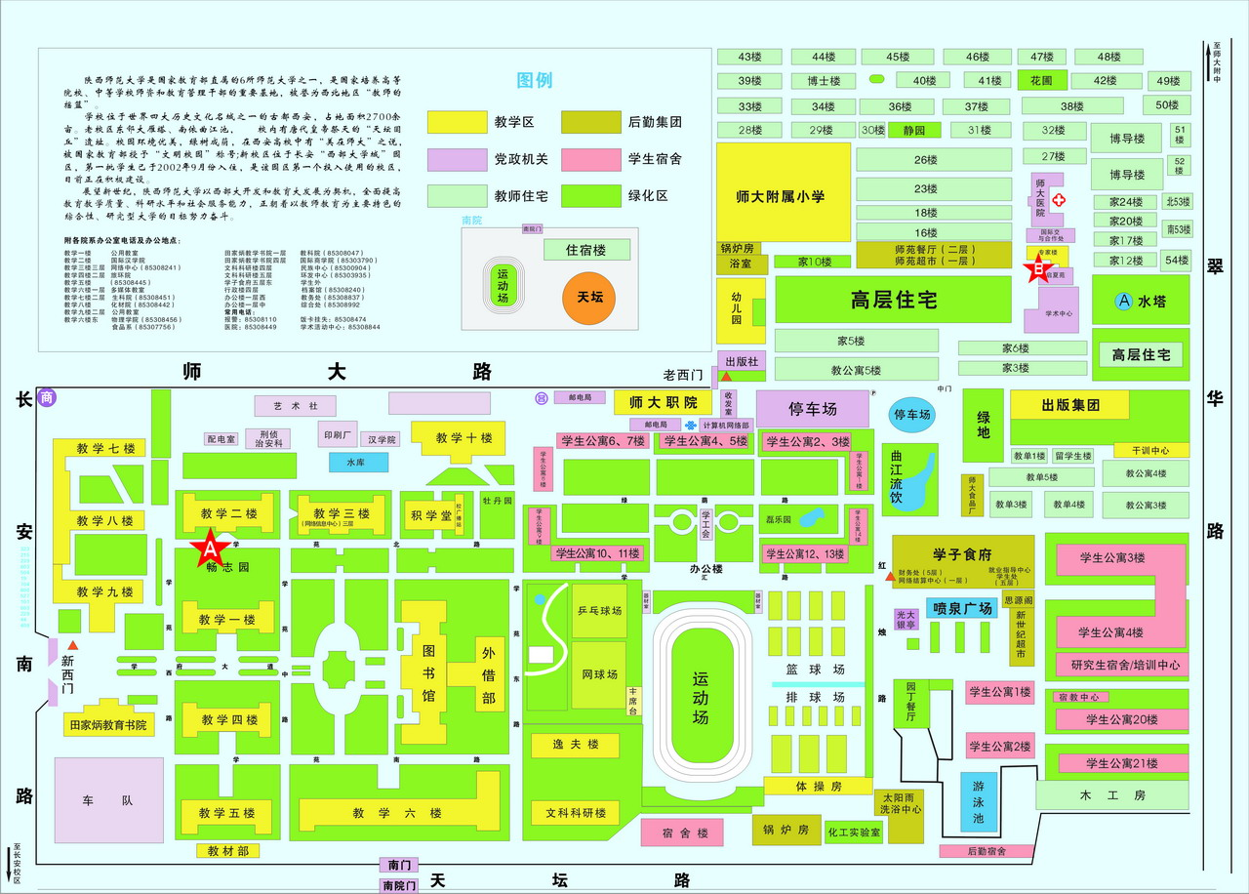
Map of Yanta Campus, SNNU 陕西师范大学雁塔校区地图
Spot A点: Classroom Building No. 2教学二楼 Spot B点: Qixiayuan hotel 启夏苑宾馆
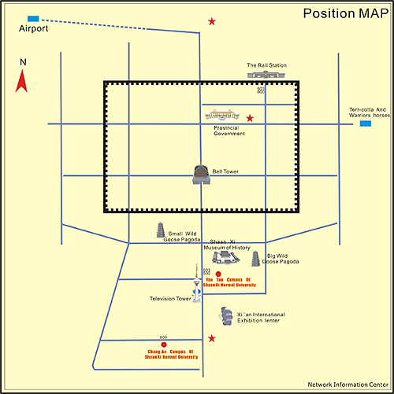
Location Map of SNNU 陕西师范大学位置图

